

**ACTIVITY REPORT**

**ON**

**Trivi Arena**

1. **Name of the Club:** BMSCE ACM Student Chapter
2. **Name of the Event:** Trivi Arena
3. **Objectives:** The BMSCE ACM Student Chapter in collaboration with BMSCE IEEE WIE organized an event named “Trivi Arena”, a tech-based trivia and puzzle competition. This event aimed to challenge participants’ technical knowledge, problem-solving skills, and ability to think quickly under pressure.
4. **Date, Time and Venue of the Event :**

| **DATE/DAY** | Monday, 17th March 2025 |
| --- | --- |
| **TIME** | 11:00 am to 1:00 pm |
| **VENUE** | PJ Block, 6th floor, Computer Science Data Science Lab |

1. **Name and details of collaborating agency (if it is collaborative/joint activity):** BMSCE IEEE WIE
2. **Brief summary of the Event:**

The event was designed to provide an enjoyable yet intellectually stimulating experience for all participants, helping them learn while having fun. It consisted of three engaging rounds, each designed to test different skills. Participants faced a mix of trivia, technical challenges, and interactive gameplay.

**Round 1: Quiz**

Participants were given 20 questions displayed on the screen. Each team had to write their answer on a sheet within 30 seconds per question. This round was for only 10 minutes. This round challenged participants' technical problem-solving abilities, testing their knowledge in various subjects.

**Round 2: Tech and Fun**

This round combined technical problem-solving with interactive gameplay, where one team member solved 12 technical questions to earn letters in 15 minutes, while the other completed 3 online games to earn points and letters, in 30 minutes. Participants earned letters from their performance in this round, which would be used later. This round blended technical problem-solving with gameplay, introducing an exciting and distinctive challenge.

**Round 3: Unscramble**

In the final round, the team got back together to find a 9 letter word using the letters they have earned using teamwork and logical reasoning to crack the puzzle. This round was for only 10 minutes.

The event encouraged participants to think critically, work together effectively, and enjoy a mix of technical and entertaining activities. The team with the highest score at the end of all three rounds was declared the winner.

1. **Outcomes:** "Trivi Arena" provided an excellent opportunity for participants to sharpen their problem-solving, teamwork, and creative thinking abilities in a dynamic and encouraging atmosphere. The event enabled every team member to play to their strengths, promoting a sense of unity and cooperative effort among all participants.
2. **Number of participants:**

| **Number of Teams** | **Number of Participants** |
| --- | --- |
| 25 | 50 |

1. **Photographs of the event:**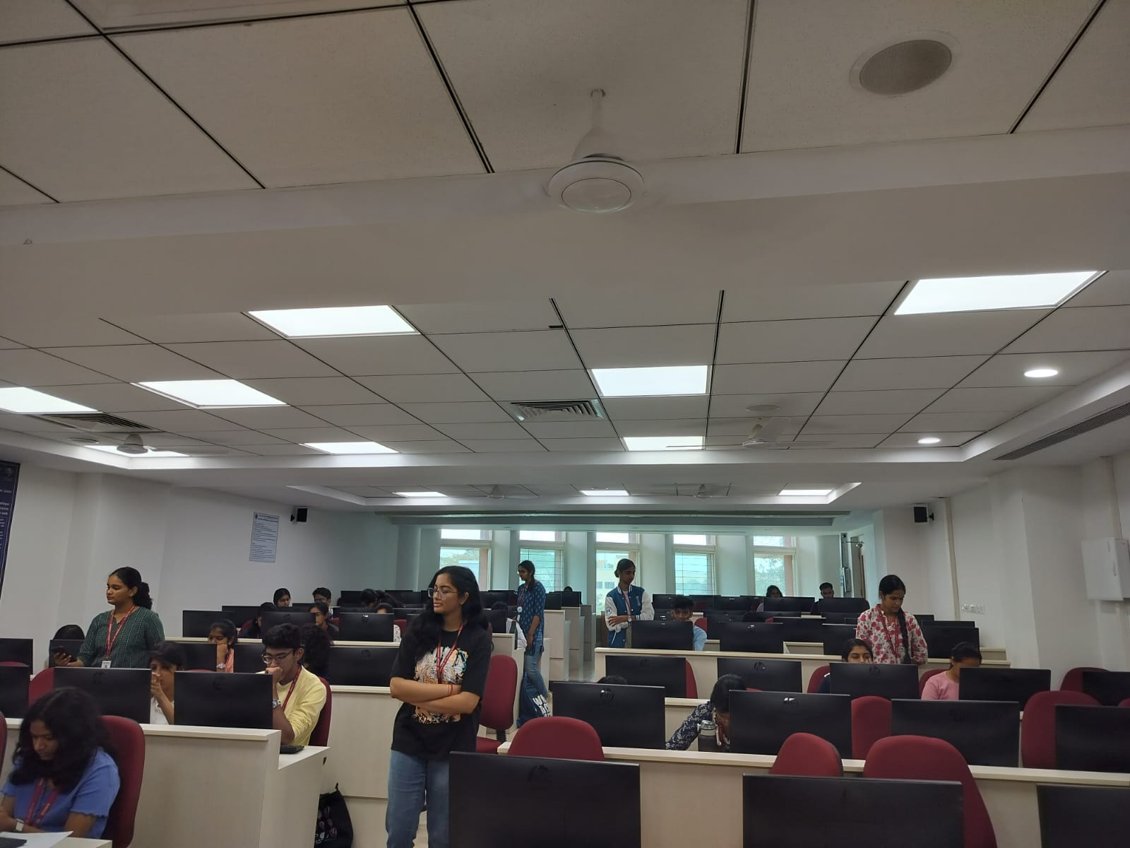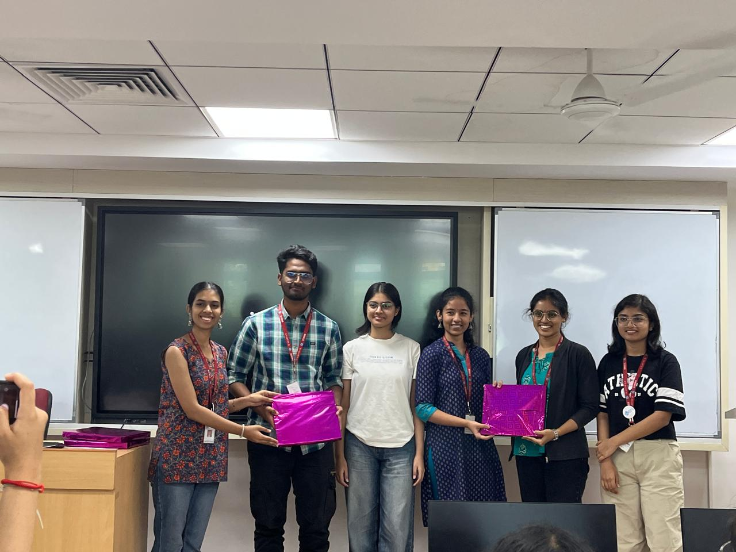

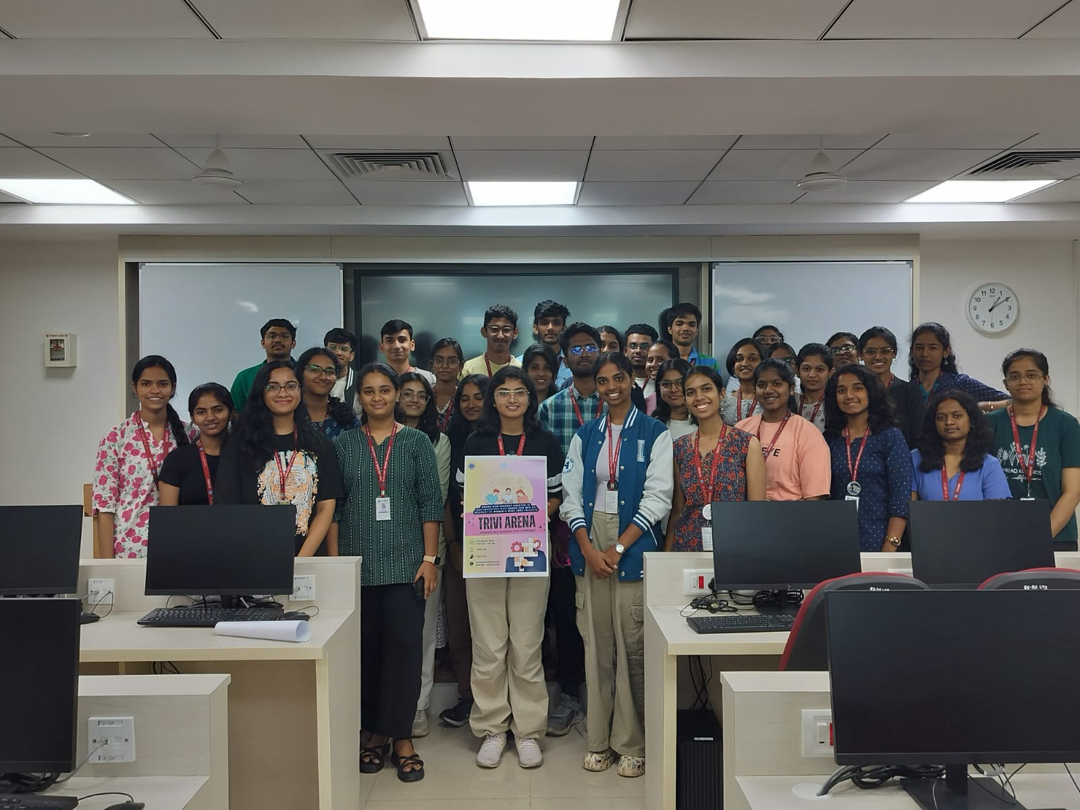

1. **Supporting Documents:**
2. **Circular Brochures:**

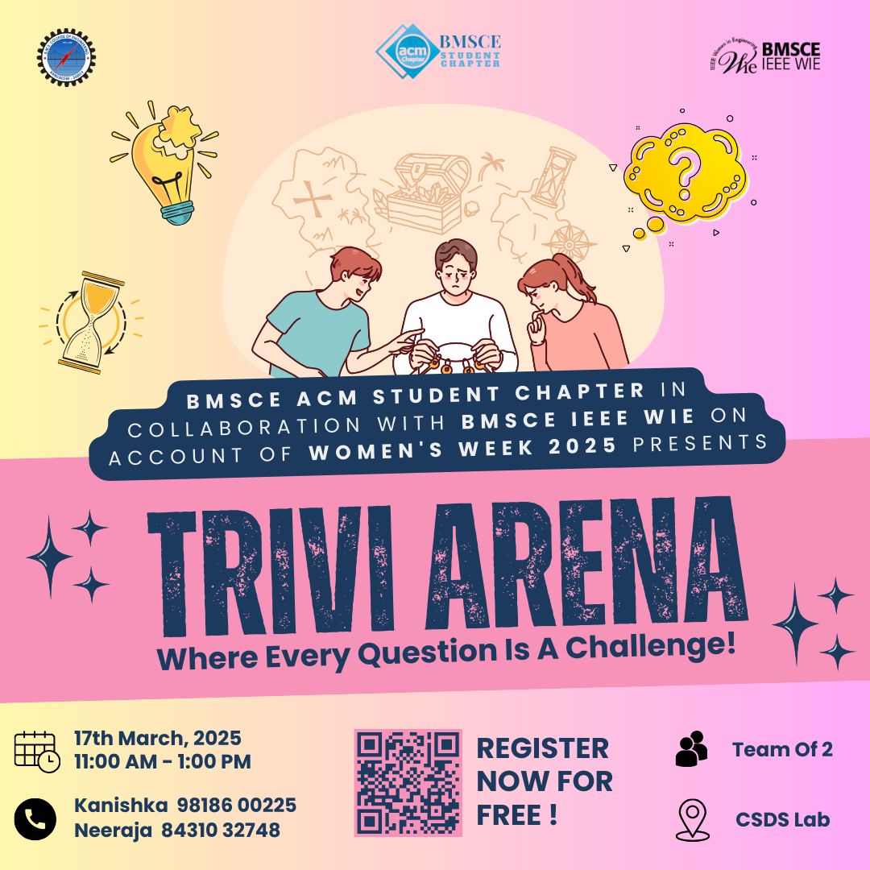

**Attendance:**



| **Team Name** | **Member 1** | **USN** | **Member 2** | **USN** |
| --- | --- | --- | --- | --- |
| The Binary | Ananya | 1BM24AI017 | Chandudarshini | 1BM24AI036 |
| Mind hunt | Chetana | 1BM23ET015 | Srivalli C M | 1BM23ET053 |
| Bye-bye | Chethan K S | 1BM23CS074 | Siddhant sahare | 1BM23CS326 |
| Unagi | Keerthana baliga | 1BM24CH028 | Dhanush g shetty | 1BM24ME029 |
| pinky pink | Ritikha Raj | 1bm23ai151 | virat malviya | 1bm23ai211 |
| Direct Counter | DARSHAN R PALRECHA | 1BM24CS091 | CHETAN B S | 1BM24CS081 |
| Vesuvius | Kirti Kumari | 1BF24CS140 | Garima Kedia | 1BM24EE021 |
| Blaze | Dyuthi | 1BM23CS097 | Hitha Harish | 1BM23CS115 |
| Why | S.Bharathwaj | 1BM24EC172 | Rakesh S | 1BM24EC162 |
| Shadow Strikers | Aishwarya M | 1BM24CS024 | Aiman kousar | 1WN24CS024 |
| Shouryanga | Hemachandra D | 1BM24CH022 | Likhith U | 1BM24CH031 |
| Noobs | Sarayu KS | 1BM23AI171 | Reem Rashid | 1BM23AI148 |
| Duolinga | Shravya R Hegde | 1BM24CS271 | Sai Sharadha Manjunath | 1BM24CS250 |
| Maths kids | Kashvi Agarwal | 1BM23CS142 | Chitrashree K | 1BM23CS081 |
| Luminex | Kamireddy Keerthi Reddy | 1BM23CS137 | Harshitha H G | 1BM23CS109 |
| A square | Akshatha R | 1WA24CS033 | Akshatha HR | 1WN24CS029 |
| Idk | Etta Pranay | 1BM24CS097 | Diya Shivakumar | 1WA24CS114 |
| Chill bruh | Namitha R | 1BM24CH041 | Leisha M | 1BM24CH030 |
| 2 broke girls | Keerthana kabbur | 1BM23EC119 | Mp Harshitha | 1BM23AI091 |
| A&S | P Sai Nieojitha | 1BM24AD036 | Ananthasai L | 1BM24AD005 |
| Fixer | Deeptanshu Sarangi | 1BF24CS094 | Chethana Bhima | 1BM24CS082 |
| Clueless | Sriranjani S | 1BM24CS288 | Sushmitha M G | 1WN24CS295 |
| Marwadis | Lalit Sureliya | 1WN24CS144 | Divyansh Duggad | 1BF24CS102 |
| Oreo | Smruthi P | 1BM24CS283 | Aravind BN | 1BM24CS050 |